Project Title: Road Traffic Accident Prediction

Group-FTL_Myanmar_Gr10

Members
- Thu Thu Win
- Ye Htet Naing
- Unt Ko
- Sai Shang Hlang
- Chaw Nu Htun

Data Preparation/Feature Engineering
1. Overview
The data preparation and feature engineering phase is critical for transforming raw data into a format that machine learning algorithms can effectively process. This phase directly impacts model performance, interpretability, and generalization capability. Proper feature engineering can often yield greater performance improvements than model selection or hyperparameter tuning alone.

2. Data Collection
The dataset used in this project was obtained from the Kaggle-Predicting Road Accident Risk which focuses on predicting the risk of road accidents based on road, environmental, and situational conditions. The dataset includes features such as road type, lighting, weather, number of lanes, curvature, and time of day.
The dataset consists of two main files:
- train.csv-contains the training data along with the target variable accident_risk.
- test.csv-contains the test data without the target variable.
During data collection, all files were imported directly using Kaggle’s public dataset links. The training dataset was checked for missing values and duplicate rows to ensure data quality. No missing values were found in the dataset, and any duplicate rows were removed to ensure the data quality before further preprocessing. The dataset was then loaded into a pandas DataFrame for further exploratory data analysis(EDA) and data preprocessing.
These steps ensured that the data was clean, reliable, and ready for model development in subsequent stages.

3. Data Cleaning
- Handling Duplicates
To prevent data redundancy and bias in the model, the following code checks for duplicate rows in the dataset. If any duplicates exist, they are removed.
duplicates = df.duplicated().sum()
if duplicates > 0:
df = df.drop_duplicates()
- Converting Boolean Data
This is to maintain consistent data types across all features. In this code, boolean (True/False) values are converted into numeric (1/0), ensuring compatibility with machine learning algorithms that require numerical inputs.
bool_cols = df.select_dtypes(include=['bool']).columns
df[bool_cols] = df[bool_cols].astype(int)
- Handling Categorical Variables
This section of the code converts string labels into machine-readable numeric values. It automatically detects categorical (text) columns. It then applies one-hot encoding to convert them into numerical format. It drops the first dummy variable (drop_first=True) to prevent multicollinearity.
categorical_cols = df.select_dtypes(include=['object']).columns
df_encoded = pd.get_dummies(df, columns=categorical_cols, drop_first=True)
- Handling Missing Values
This is to ensure no missing data remains while preserving distribution characteristics. The code uses a two-step imputation strategy:
- Numeric columns → Missing values are filled with the median (robust against outliers).
- Categorical columns → Remaining missing values are filled with the mode (most frequent value).
df_encoded = df_encoded.fillna(df_encoded.median(numeric_only=True))
df_encoded = df_encoded.fillna(df_encoded.mode().iloc[0])
- Outlier Detection (Visualization)
This step detects extreme values that could influence model performance. Boxplots are generated for all numeric features to visualize the presence of outliers. Outliers are not automatically removed, but this step helps in identifying them visually.
plt.figure(figsize=(10,6))
df[numeric_cols].boxplot()
plt.title("Boxplots of Numeric Features")
plt.show()
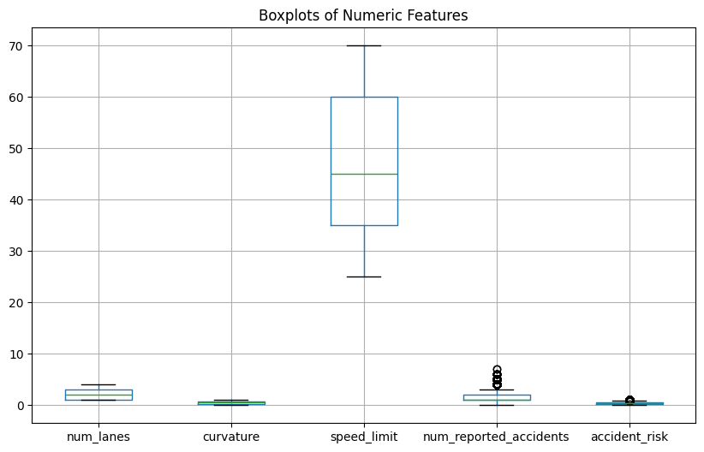
- Data Type Consistency Check
After encoding, the code re-checks for boolean types and converts them to integers again to ensure that no newly generated boolean columns remain unconverted.
bool_cols = df_encoded.select_dtypes(include=['bool']).columns
df_encoded[bool_cols] = df_encoded[bool_cols].astype(int)
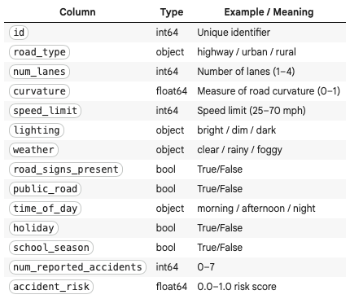

4. Exploratory Data Analysis (EDA)
The EDA process systematically examined the road accident risk dataset to understand its structure, distributions, relationships, and data quality before modeling.
- Data Structure Analysis
summary_info = {
"shape": df.shape,
"columns": df.columns.tolist(),
"dtypes": df.dtypes.to_dict(),
"missing_values": df.isnull().sum().to_dict(),
"basic_statistics": df.describe(include='all').transpose()
}
This reveals shapes, columns, data types, missing values and basic statistics, and finds that there’s no missing values.
- Distribution Analysis
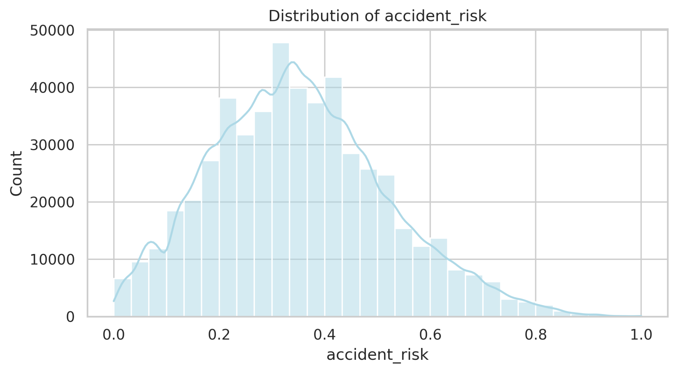
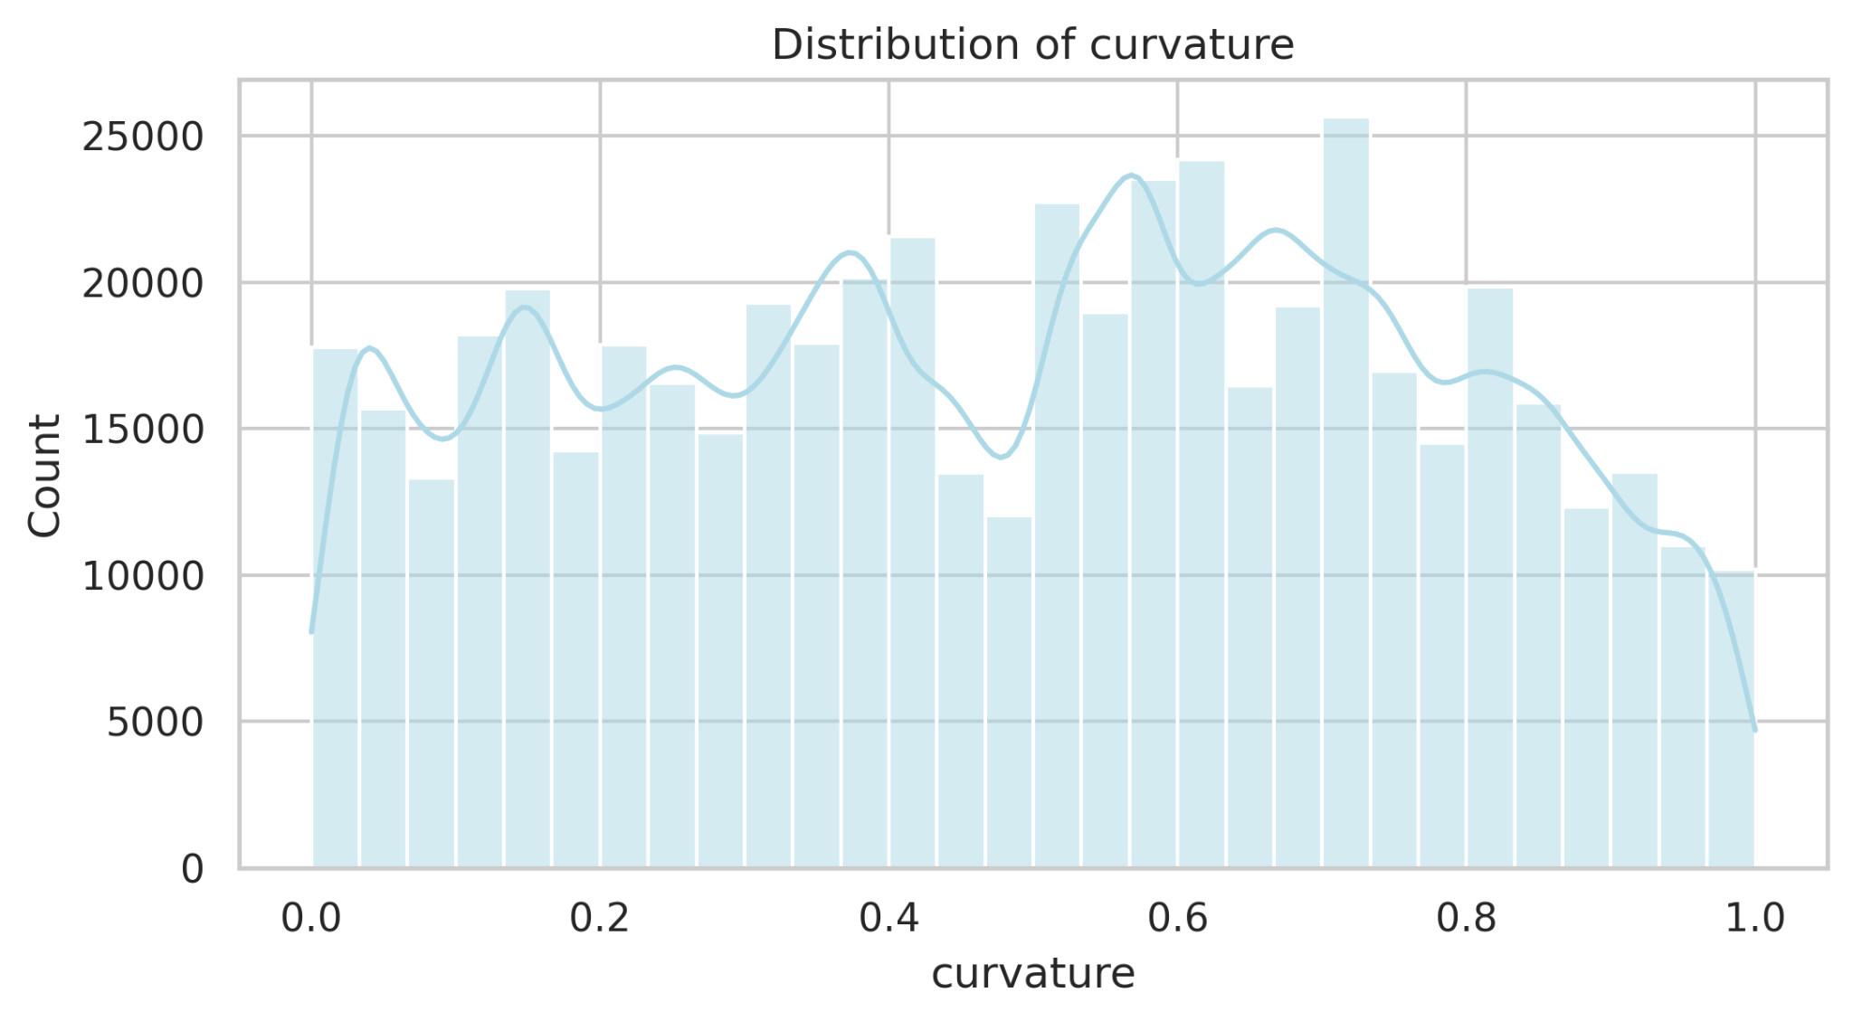
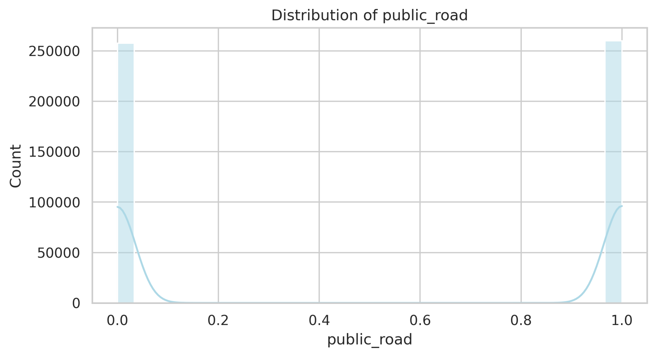
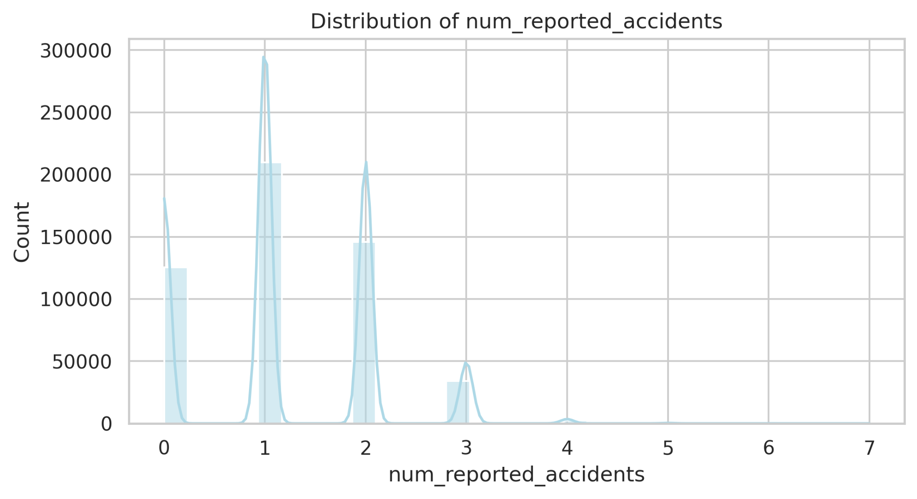
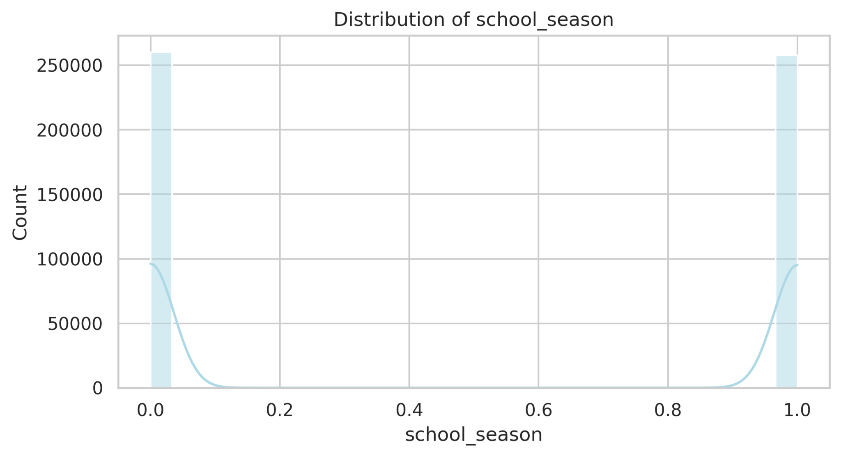
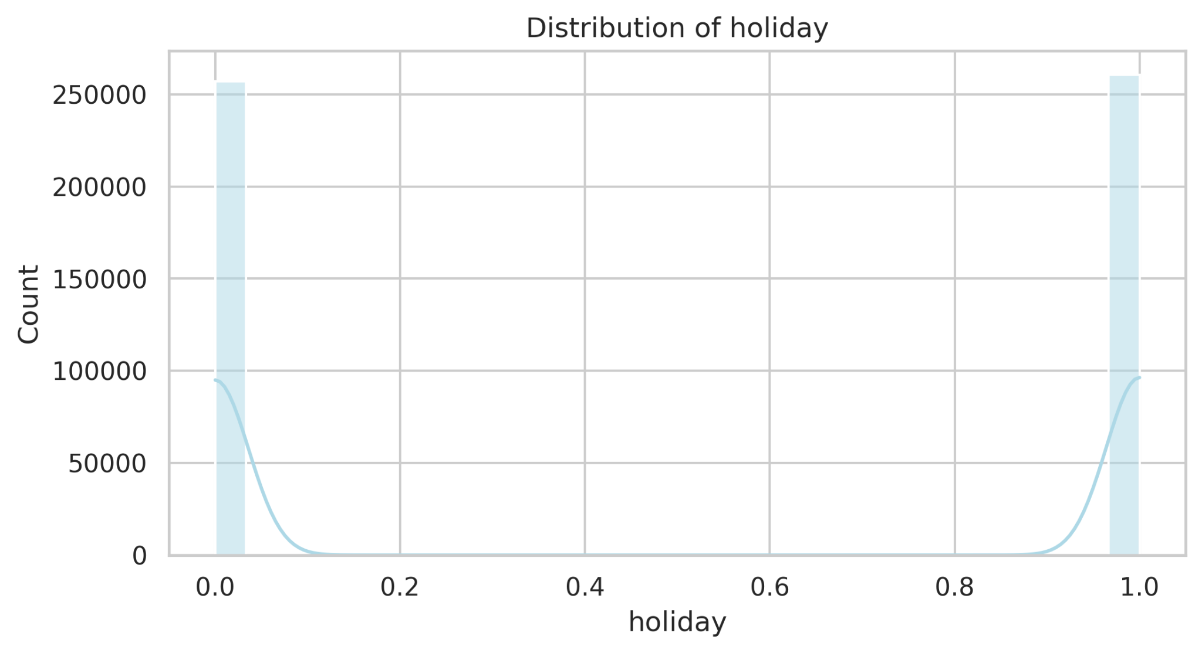
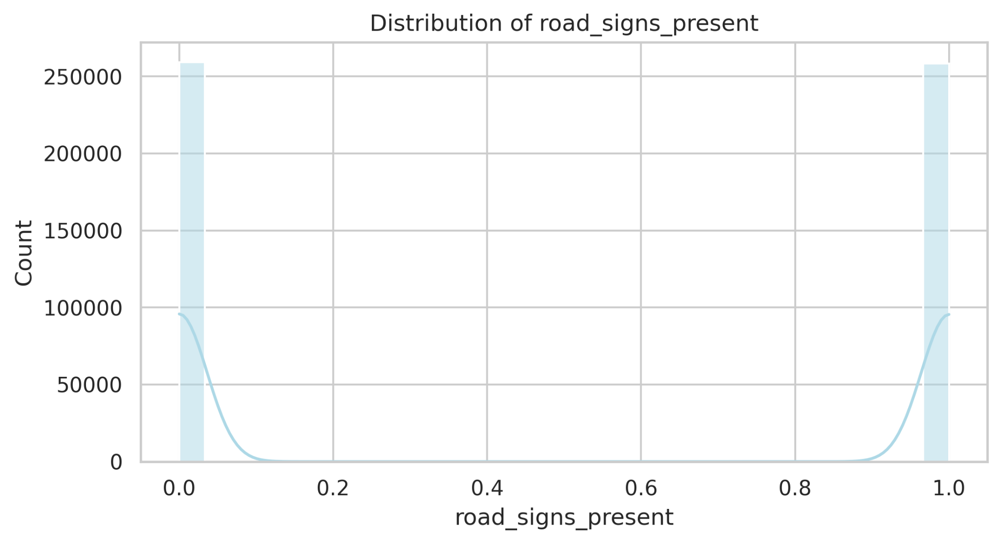
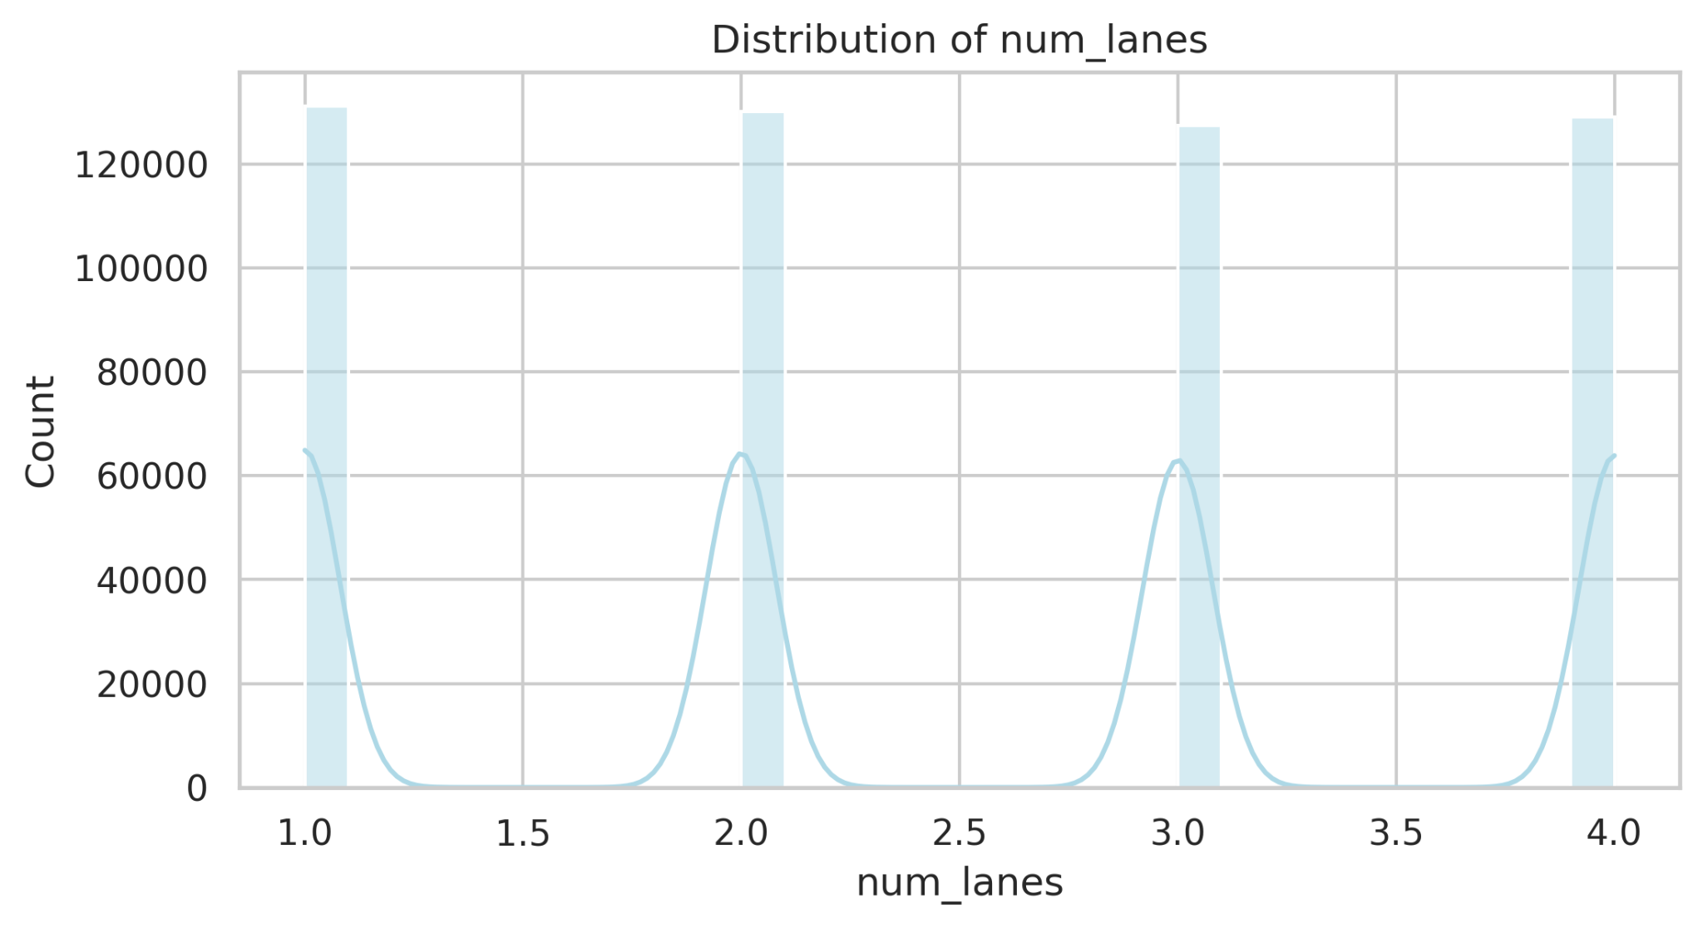
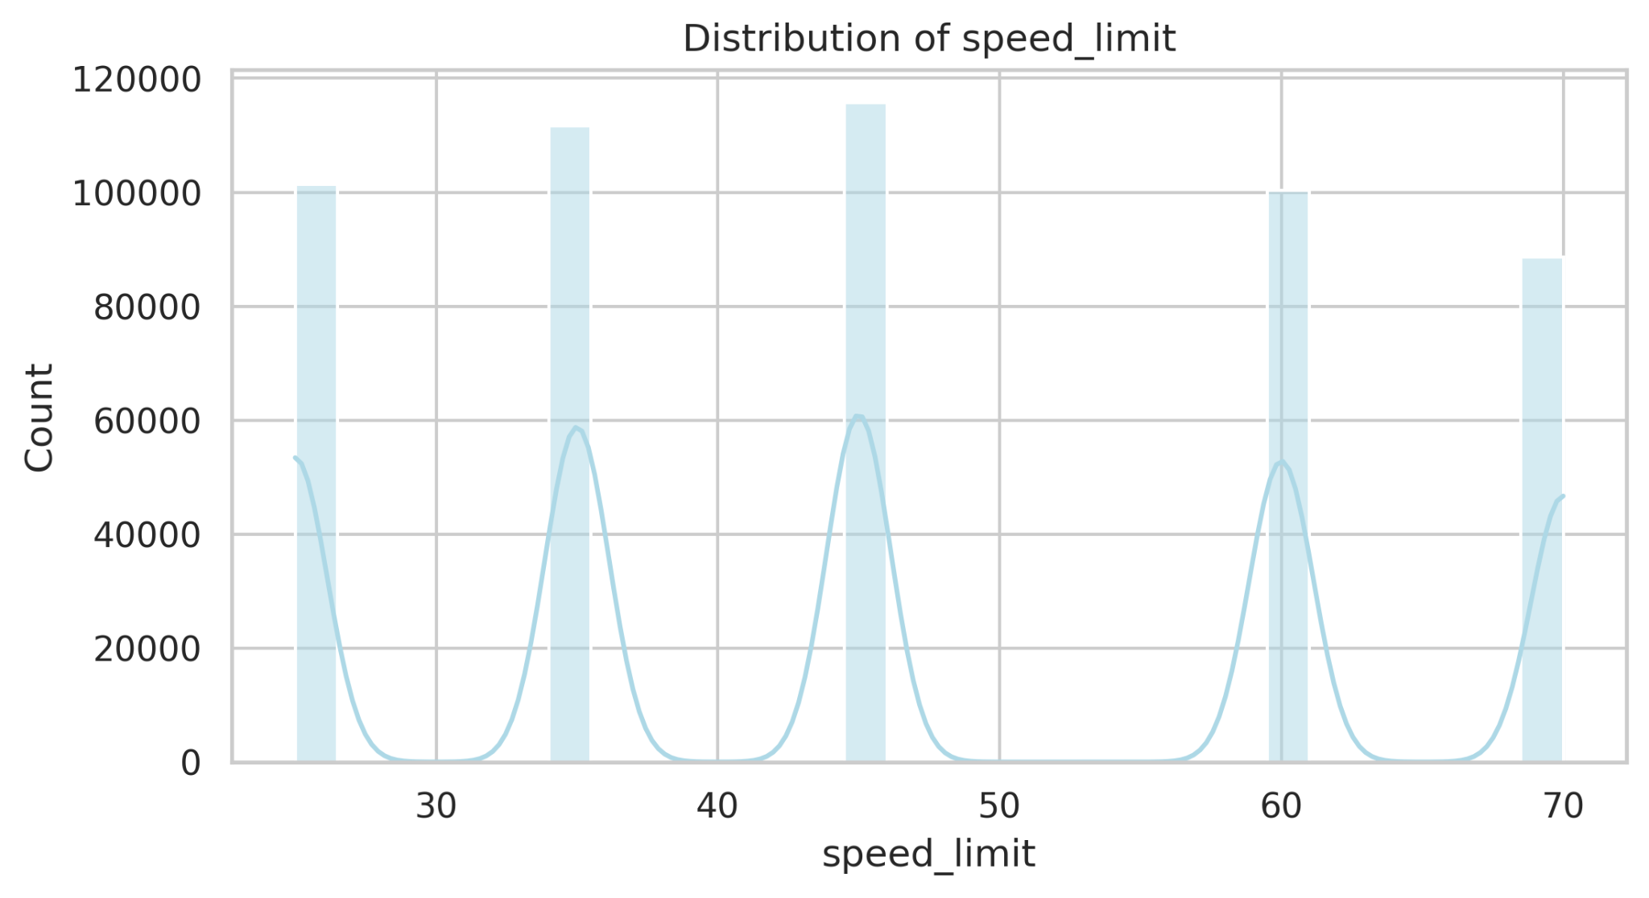

- Correlation Analysis
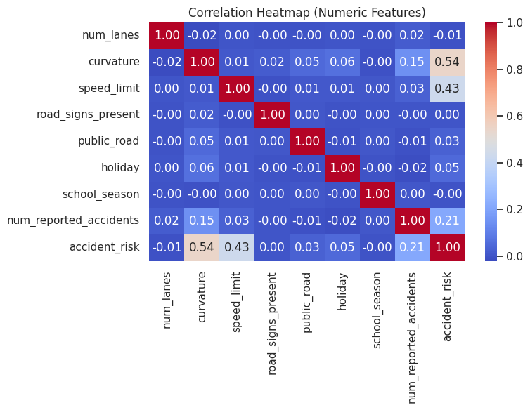

5. Feature Engineering

One-Hot Encoding for Categorical Variables
categorical_cols = df.select_dtypes(include=['object']).columns
df_encoded = pd.get_dummies(df, columns=categorical_cols, drop_first=True)
- Converts categorical text data into numerical format that ML models can process
- ‘drop_first=True’ prevents multicollinearity (dummy variable trap)
- Creates binary features that are easily interpretable by tree-based models
- Avoids imposing arbitrary ordinal relationships (e.g., assuming "bright" > "dim" > "dark")

Boolean to Integer Conversion
bool_cols = df.select_dtypes(include=['bool']).columns
df[bool_cols] = df[bool_cols].astype(int)
- Boolean columns (road_signs_present, public_road, holiday, school_season) need to be converted to numerical format (0/1) for machine learning algorithms
- Most ML models cannot handle boolean data types directly
- Integer representation allows models to interpret these as binary categorical variables
- Enables mathematical operations and distance calculations in algorithms

Secondary Boolean Conversion
bool_cols = df_encoded.select_dtypes(include=['bool']).columns
df_encoded[bool_cols] = df_encoded[bool_cols].astype(int)
- One-hot encoding creates boolean columns that also need conversion
- Ensures consistency across all features
- Prevents potential issues with models that might not handle mixed data types

6. Data Transformation
In this step, several preprocessing techniques were applied to prepare the dataset for model training. These transformations ensure that all features are in a suitable format for machine learning algorithms and that no data inconsistencies affect performance.
- Handling Boolean Values
The dataset originally contained boolean columns such as road_signs_present, public_road, holiday and school_season.
These were converted into numerical format(0 and 1) using:
bool_cols = df.select_dtypes(include=['bool']).columns
df[bool_cols] = df[bool_cols].astype(int)

- Encoding Categorical Variables
Categorical (text) columns such as road_type, lighting, weather and time_of_day were encoded using one-hot encoding. This creates new binary columns for each category while preventing redundancy using drop_first=True option:
categorical_cols = df.select_dtypes(include=['object']).columns
df_encoded = pd.get_dummies(df, columns=categorical_cols, drop_first=True)
The dummy columns generated by get_dummies() are boolean (True/False), so they were converted to integer format(1/0) to ensure all features are numeric for model training.
This transformation allows models like Random Forest, XGBoost and SVR to understand categorical relationships numerically without introducing bias from arbitrary integer labels.
- Handling Missing Values
Although the dataset did not contain missing values, the code includes fallback handling using the median for numeric columns and the mode for categorial columns:
df_encoded = df_encoded.fillna(df_encoded.median(numeric_only=True))
df_encoded = df_encoded.fillna(df_encoded.mode().iloc[0])
This ensures robustness in case missing values appear in other datasets or during deployment.
- Feature Scaling (for SVR)
Since Support Vector Regression (SVR) is sensitive to the scale of input features, data was standardized using StandardScaler:
from sklearn.preprocessing import StandardScaler
scaler = StandardScaler()
X_train_scaled = scaler.fit_transform(X_train)
X_test_scaled = scaler.transform(X_test)
Standardization transforms features to have zero mean and unit variance, improving the performance and convergence of SVR.Tree-based models like Random Forest and XGBoost were trained on the unscaled data since they are not affected by feature scaling.
Model Exploration
1. Model Selection
XGBoost (Extreme Gradient Boosting) was chosen for the following reasons:
- High predictive performance
- Robustness to different features types
- Built-in regularization
- Cross-validation integration
XGBoost offers several strengths that make it suitable for accidents risk prediction analysis. Its gradient boosting framework combines multiple decision trees to reduce bias and variance, resulting in high predictive accuracy. The model can efficiently handle heterogeneous features, including numeric, boolean, and one-hot encoded categorical variables. Additionally, XGBoost can internally manage missing values and supports a variety of evaluation metrics, such as RMSE and R². Here is the evidence from the results:
XGBoost Regressor:
- Mean Squared Error (MSE): 0.0032
- Root Mean Squared Error (RMSE): 0.0564
- R-squared (R2): 0.8850
The model also has some limitations. Its ensemble nature makes it more complex and less interpretable than linear models, and its performance is sensitive to hyperparameter tuning, requiring careful adjustment of parameters like learning rate, tree depth, and number of estimators. Training time and memory usage can also increase substantially for datasets with many features, particularly after one-hot encoding, which may affect scalability for very large datasets.

2. Model Training
The model was trained using the XGBoost Regressor, a gradient boosting algorithm known for its high accuracy and efficiency on tabular data.
- The dataset was first split into training (80%) and testing (20%) subsets using the train_test_split() function with a fixed random state(2025) to ensure reproducibility.
- For model training, an XGBRegressor from the xgboost library was initialized with default hyperparameters such as n_estimators=100,learning_rate=0.3, max_depth=6, subsample=1.0 and colsample_bytree=1.0 and a fixed random_state=2025.
- The model was fitted on the training set(X_train,y_train) without additional tuning to establish a baseline performance.
- To further validate the model’s robustness, 5-fold cross-validation was applied using KFold strategy with shuffling enabled.

3. Model Evaluation
The performance of the XGBoost Regressor was evaluated using the test set (X_test, y_test). Several metrics and visualizations were used to assess the model:
Evaluation Metrics and Visualizations:
- Mean Squared Error(MSE):Measures the average squared difference between predicted and actual values.
MSE=0.0032
- Root Mean Squared Error(RMSE): Square root of MSE, representing prediction error in the original units.
RMSE=0.0564
- R-squared (R²): Proportion of variance in the target explained by the model.
R²=0.8850

- Predicted vs Actual Plot: Shows how closely the model’s predictions match the true values. Points near the diagonal line indicate accurate predictions.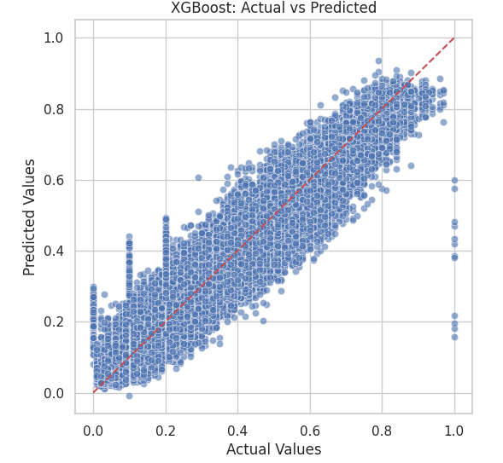
- Residual Plot: Plots prediction errors (Actual-Predicted) against predicted values to detect patterns or bias. A random scatter around zero indicates unbiased predictions.
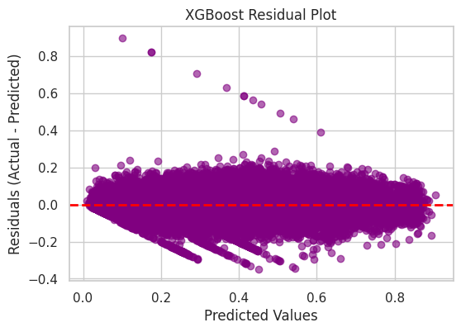
- Distribution of Residuals: Histogram of errors to examine whether the residuals are approximately normally distributed.
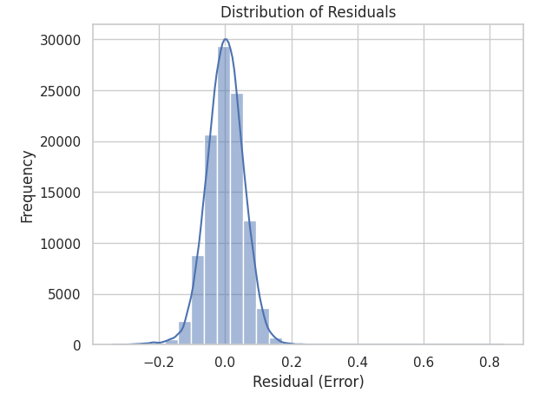
- Feature Importance Plot: Highlights which features contributed most to the model’s predictions, based on gain( improvement in accuracy when a feature is used in splits).
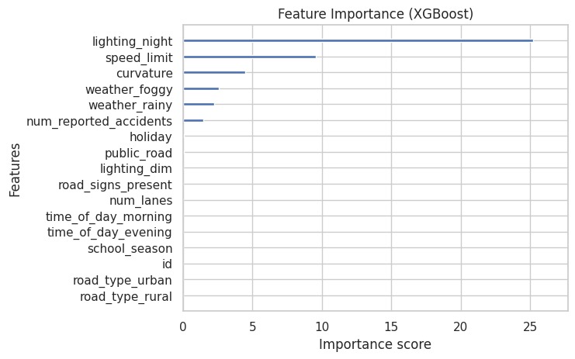
4. Code Implementation
Include relevant code snippets for both data preparation/feature engineering and model exploration. Use comments to explain key sections of the code.
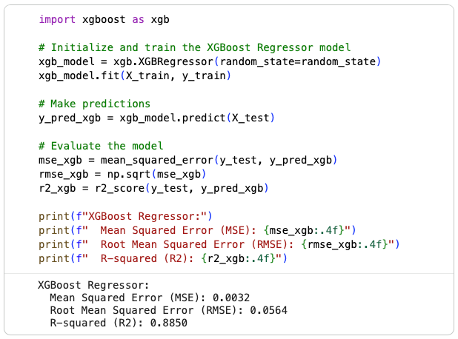
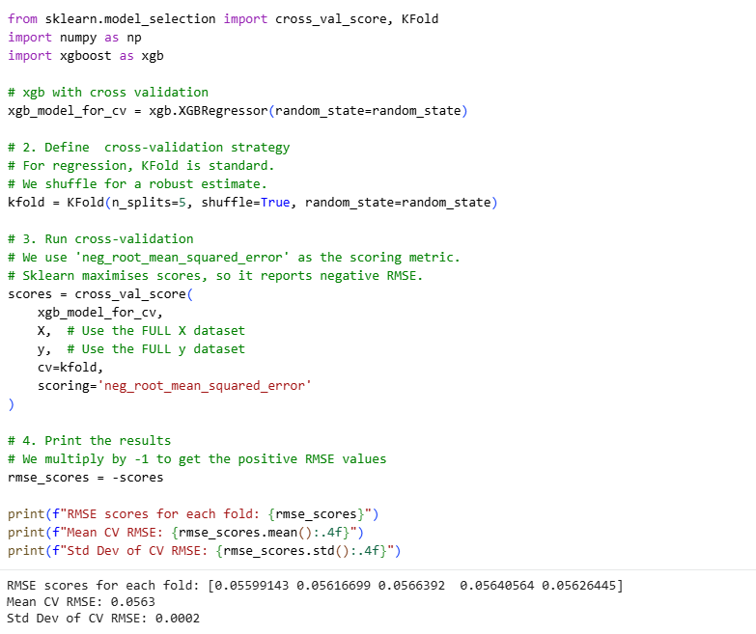
Please provide images from your data and models (I want to see different visualizations in EDA part as we did pair coding session )!!!!
